# What is HTML?

* HTML-<b> Hypertext Markup</B>Language
* It is a language for describing web pages using ordinary text.
* The makup tell the web browser how to display a web page’s word for the user.
* Every web page is actually a HTML file

# Part of HTML file

* logo
* Header
* Dropdown menus
* Category menus
* Slide/splits
* Footer

# Page source

HTML everything is written in Tags

<html>

</html>

Webpage is build with in Tags; web site is collection of web pages.

Normally web page is consisting of text and images, videos etc.

* Hypertext
* Markup-coding

---------------

Every web page is actually a HTML file

What do we required – simple note pad

Search engine –chrome

# Structure of the HTML file

<html>

<head>

<title>

</title>

</head>

<body>

</body>

</html>

# Components to build HTML file

* Javascript
* CSS
* Jquery, Angluar JS

# About HTML5

Now we are using HTML5

We have different version

Version Year

HTML 3.2 1997

HTML 4.01 1999

XHTML 2000

HTML5 2014

In 1989, Berners-Lee wrote a memo proposing an Internet-based hypertext system. Berners-Lee specified HTML and wrote the browser and server software in late 1990.

**Bootstrap**

* Bootstrap is very common now days for developing UI of web page. It is free open source and it is most popular html,css,javascript framework developer by twitter
* Bootstrap imost effective with less efforts
* **Bootstrap styles**
* BS Bullets
* BS Pannel
* BS Tables, Navigations, Tabs, Forms along options JavaScript extinctions
* Supports responsive web design.(small screen /large screens)

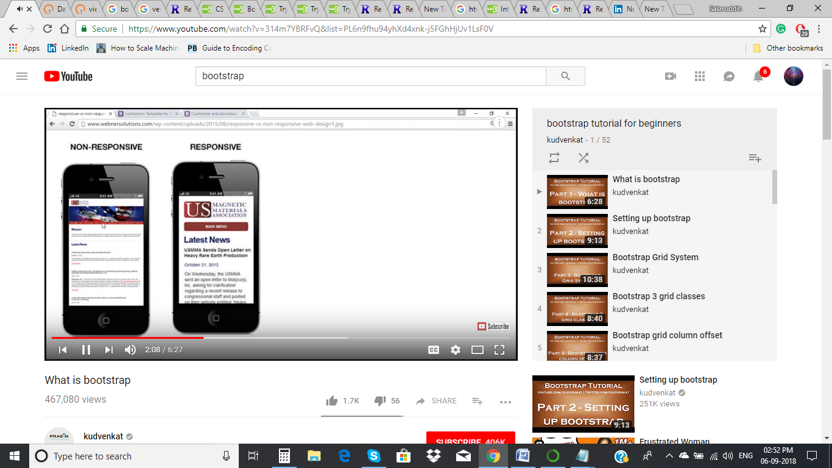

* Saves lot and time and development code. We can use already define code in Bootstrap
* Almost every browser supports Bootstrap.

**What are the requirements to use bootstrap?**

* Html
* Css
* Javascript

**Benefits**

* Mobile first approach
* Browser support
* Easy to start
* Responsive design

Useful links

[**http://rendera.herokuapp.com/**](http://rendera.herokuapp.com/)

[**https://www.w3schools.com/html/default.asp**](https://www.w3schools.com/html/default.asp)

[**https://www.w3schools.com/css/default.asp**](https://www.w3schools.com/css/default.asp)

[**https://www.w3schools.com/bootstrap/bootstrap_get_started.asp**](https://www.w3schools.com/bootstrap/bootstrap_get_started.asp)